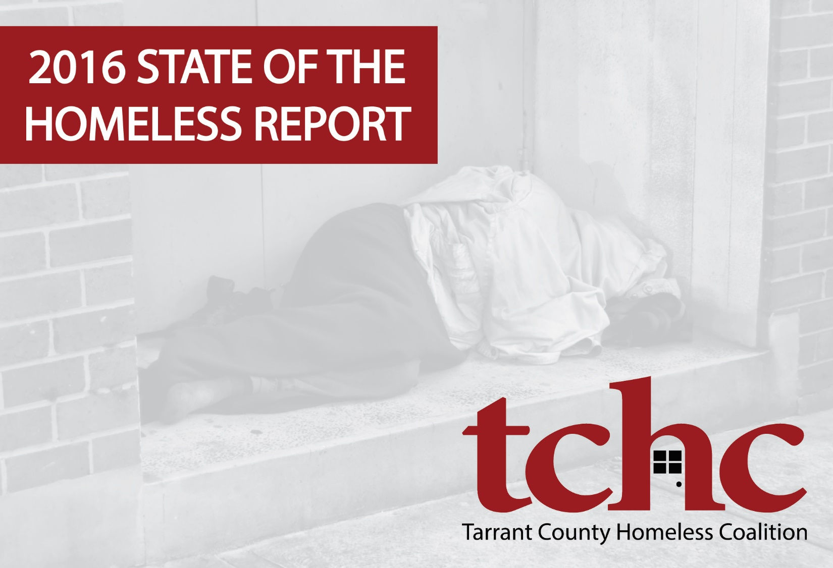

Table of Contents

1 Executive Summary 4
2 Introduction 6
2.1 History, Scope, and Geography 6
3 Terms Used in this Report 7
3.1 Continuum of Care 7
3.2 Homelessness 7
3.3 Chronic Homelessness 8
3.4 Housing Types 9
4 Methods, Data Sources, and Limitations 10
4.1 Point-in-time Count 10
4.1.1 Sheltered PIT Count Methods 10
4.1.2 Unsheltered PIT Count Methods 11
4.2 Youth Count 11
4.3 Limitations 11
5 Counts and Trends 12
5.1 Total Population 12
5.1.1 Geographic Distribution 12
5.1.2 Demographics 13
5.2 Unsheltered 15
5.2.1 Geographic Distribution 15
5.2.2 Demographics 18
5.3 Emergency Shelter 20
5.3.1 Geographic Distribution 20
5.3.2 Demographics 21
5.4 Transitional Housing 23
5.4.1 Geographic Distribution 23
5.4.2 Demographics 23
5.5 Safe Haven 25
5.5.1 Geographic Distribution 25
5.5.2 Demographics 25
5.6 Families and Youth 26
5.7 Veterans 27
5.8 Chronically Homeless 28
5.9 Sub-populations 28
6 Other Individuals in the Care of the Homeless Services System 28
6.1 Individuals in Permanent Supportive Housing 28
6.2 Individuals in Rapid Re-housing 30
7 Annualized Count 31
7.1 Documentation of Priority Status 31
8 Discussion 31
8.1 Homeless Helpline 33
8.2 Causes and Impediments 33
8.2.1 Availability of Affordable Housing 34
8.2.2 Employment and Poverty 35
8.2.3 Domestic Violence 36
8.3 Functional Zero: What Does it Mean to End Homelessness? 37
9 TCHC Recommendations 37
9.1 Common Agenda 40
9.2 Shared Measures 40
9.3 Mutually Reinforcing Activities 40
9.4 Constant Communication 41
9.5 Backbone Organization 41
10 About TCHC 41
11 Acknowledgements 42

Citation: Tarrant County Homeless Coalition State of the Homeless
Report, 2016, www.AHomeWithHope.org

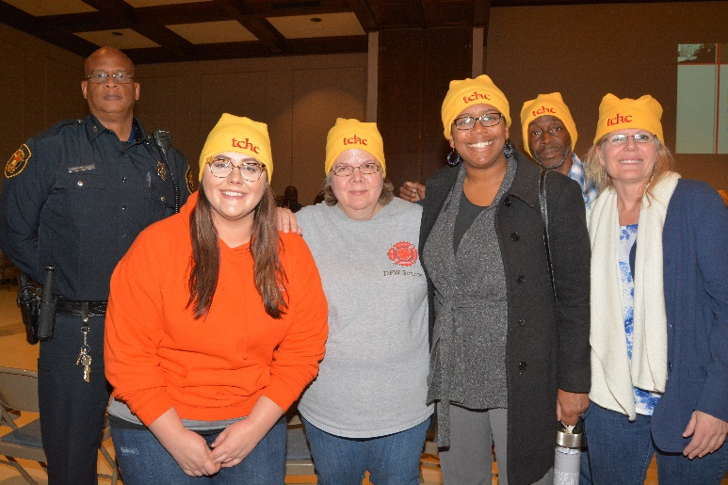

More than 400 volunteers contributed their time and enthusiasm to make this year’s “Count Night” a success. On January 28th, they joined around 100 police officers and the staff of Tarrant County Homeless Coalition to canvass Tarrant and Parker Counties. This report would not be possible without their generosity and community spirit.

Executive Summary
Counts and Trends
The 2016 point-in-time count of people experiencing homelessness in Tarrant and Parker counties is 1,938—an increase of 24 people, or 1.25%. The homeless population continues to shrink as a percentage of the overall population and remains below one percent.
 | Unsheltered | Emergency  Shelter | Safe  Haven | Transitional  Housing | Total | Annual  Change
2016 | 423 | 1,088 | 20 | 407 | 1,938 | +1.25%
2015 | 217 | 1,245 | 20 | 432 | 1,914 | -21.07%
2014 | 184 | 1,273 | 20 | 948 | 2,425 | +1.46%
2013 | 281 | 1,126 | 18 | 965 | 2,390 | +10.19%
2011 | 136 | 1,193 | 20 | 927 | 2,169 | -<1%
2009 | 195 | 1,148 | 20 | 818 | 2,181 | --

While homelessness on the western side of the metroplex continues to be concentrated in Fort Worth, increases were identified this year in both Arlington and Parker County.
 | UN | ES | SH | TH | Percent  of Total | 2016  Total | 2015  Total | Annual  Change
Fort Worth | 341 | 950 | 20 | 173 | 77% | 1,484 | 1,485 | -.07%
Arlington | 61 | 138 | 0 | 134 | 17% | 333 | 279 | +19%
Parker County | 6 | 0 | 0 | 0 | 0.3% | 6 | 1 | +500%
NE Tarrant | 15 | 0 | 0 | 100 | 6% | 115 | 149 | -23%
Total | 423 | 1,088 | 20 | 407 | -- | 1,938 | 1,914 | +1.25%

The people enumerated on “Count Night” were predominately single (70%) and male (62%). While a majority (68%) were between the ages of 25 – 64, a significant portion (20%) were under the age of 18. The homeless population continues to be disproportionate to the overall population of Tarrant and Parker Counties in terms of both race and ethnicity:
 | Tarrant  County | Parker  County | Homeless  Population
African-American | 15.2% | 1.7% | 39%
White | 70.5% | 93.7% | 53%
Hispanic | 27.3% | 11% | 13%

Unsheltered Homelessness
On the night of January 28, 2016, more than 400 volunteers and around 100 members of law enforcement canvassed Tarrant and Parker Counties, counting 423 people who were sleeping in places not intended for human habitation.
 | Fort  Worth | Arlington | Parker  County | NE  Tarrant | Total | Annual  Change
2016 | 341 | 61 | 6 | 15 | 423 | +95%
2015 | 166 | 34 | 1 | 16 | 217 | +18%
2014 | 161 | 16 | 1 | 6 | 184 | -35%
2013 | 247 | 28 | 1 | 5 | 281 | --

Partial explanations for the increase could include: unseasonably warm weather on Count Night, improved reconnaissance, and a dip in the number of people staying inside emergency shelters. As noted in the report, while panhandling is a good indicator that someone is in crisis, it is not a surefire sign that they are homeless.
Reasons People Became Homelessness
Shortages of affordable child care, public transportation, and background-friendly employers certainly hinder the ability of low-income households to thrive. Reasons cited for becoming homeless included:
 | 2015 |  | 2016
 | Men | Women | Men | Women
 | Inability to afford rent | Inability to afford rent | Unemployment | Inability to afford rent
 | Unemployment | Domestic Violence | Inability to afford rent | Unemployment
 | Physical/ Mental Disability | Unemployment | Addictions/ Substance Abuse | Family/ Personal Illness

Discussion
While an increase is never welcome, low-income households faced significant obstacles in the just-ended year and our community appears to be doing better than some other large cities. Nationally, household incomes fell between 2001 and 2014 at the same time rents were going up. On the positive side, the homeless services system appears to be increasing its efficiency and volume. As new rapid re-housing programs have come online, families constitute a smaller number and percentage of the overall homeless population.
The shortage of housing that is affordable to the lowest-income renters in Tarrant and Parker Counties continues to be the greatest cause of homelessness and one of the most significant impediments to escape. With apartment vacancy rates in the area around 5%, very-low income renters struggle to compete with higher income renters for a small number of units.
For TCHC, ending homelessness means that in any given month more people will exit homelessness than fall into it. Operationalized in this way, the goal of ending homelessness acknowledges the reality that people will continue to experience housing crisis and focuses efforts on reducing the trauma and public expense of homelessness by decreasing the time anyone must suffer it.

Introduction
The Tarrant County Homeless Coalition is pleased to release this 2016 State of the Homeless Report. The data in this report describe the extent of homelessness and the characteristics of people experiencing homelessness in Tarrant and Parker Counties in North Central Texas.
The spatial, behavioral, and psycho-spiritual dynamics of homelessness and homeless services challenge our efforts to describe it with precision: people who are homeless move around, change plans, dream, despair, hope, and do their best to get what they need from a complex and layered system of care. While not without limitations (discussed below), this report represents the largest and most comprehensive census of the homeless in our community and its results are utilized by the U.S. Department of Housing and Urban Development (HUD) and other public and private entities to establish policy and award funding.
It is our hope that policymakers and practitioners, funders and philanthropist, students, researchers, and the public will find this report an accessible contribution to ongoing efforts to increase the speed, efficiency, and success of our shared efforts to return individuals and families to permanent housing.

History, Scope, and Geography
The McKinney-Vento Act was signed into law by President Reagan in 1987 and was the first of its kind, on a national level, to address homelessness. Twenty-two years later, the Homeless Emergency Assistance and Rapid Transition to Housing Act of 2009 (HEARTH Act) was signed into law in 2009 by President Obama to provide additional resources and opportunities for communities to address the issue of homelessness. The HEARTH Act expanded the definition of homelessness and combined several HUD (Housing and Urban Development) programs into a single Continuum of Care program.
The HEARTH Act mandates that communities quantify the level of need in their area and the effectiveness of community-wide interventions. The Point-in-Time Count (PIT Count) accomplishes both of these tasks.
Reports have been issued on the extent and characteristics of the homeless population in Tarrant County since 1994. Early reports were published by Tarrant County Homeless Coalition with staffing support provided by Tarrant County Community Development Division. These reports relied on counts conducted inside shelters, limited canvassing of the unsheltered by volunteers, and estimation methods.
Counts and surveys have been completed in:

1994
1997
2000
2002
2004
2006
2007
2009
2011
2013
2014
2015
2016

The 2007 count was the first to utilize the Homeless Management Information System (HMIS) and include a robust “street count” in Arlington. Parker County has been included in the PIT count since 2014.
The cities of Arlington and Fort Worth both utilized the 2007 count as baseline data for their respective ten-year plans. Subsequent PIT counts have utilized both HMIS to enumerate people sleeping inside shelters and volunteers to canvas areas within Tarrant and Parker Counties to count people who were sleeping unsheltered.

Terms Used in this Report

Continuum of Care
The work of ending homelessness in a community is carried out by a Continuum of Care—the collective networks, institutions, and organizations that provide housing and services to people who are experiencing homeless. Each Continuum of Care (or, “CoC”) serves a designated geography and is responsible for: operating the Continuum of Care, administering an HMIS (Homeless Management Information System); 3) planning for the CoC; and, 4) applying for competitive CoC Program funding from HUD.
Each Continuum of Care appoints an entity (or entities) to lead its strategic, administrative, and information technology efforts. Locally, the Fort Worth/ Arlington/ Tarrant County Continuum of Care (also known by its HUD designation, “TX-601”) has selected Tarrant County Homeless Coalition to serve as its “Lead Agency”, “HMIS Administrator”, and “Collaborative Applicant”. The service area of TX-601 includes Tarrant and Parker Counties.

Homelessness
The HEARTH Act and subsequent rulemaking by HUD set out the definition of homelessness employed in this report. This Federal definition includes four categories:
Category 1 | Literally Homeless | (1) Individual or family who lacks a fixed, regular, and adequate nighttime residence, meaning: (i) Has a primary nighttime residence that is a public or private place not meant for human habitation; (ii) Is living in a publicly or privately operated shelter designated to provide temporary living arrangements (including congregate shelters, transitional housing, and hotels and motels paid for by charitable organizations or by federal, state and local government programs); or (iii) Is exiting an institution where (s)he has resided for 90 days or less and who resided in an emergency shelter or place not meant for human habitation immediately before entering that institution

Category 2 | Imminent Risk of Homelessness | (2) Individual or family who will imminently lose their primary nighttime residence, provided that: (i) Residence will be lost within 14 days of the date of application for homeless assistance; (ii) No subsequent residence has been identified; and (iii) The individual or family lacks the resources or support networks needed to obtain other permanent housing
Category 3 | Homeless under other Federal statutes | (3) Unaccompanied youth under 25 years of age, or families with children and youth, who do not otherwise qualify as homeless under this definition, but who: (i) Are defined as homeless under the other listed federal statutes; (ii) Have not had a lease, ownership interest, or occupancy agreement in permanent housing during the 60 days prior to the homeless assistance application; (iii) Have experienced persistent instability as measured by two moves or more during in the preceding 60 days; and (iv) Can be expected to continue in such status for an extended period of time due to special needs or barriers
Category 4 | Fleeing/ Attempting to Flee Domestic Violence | (4) Any individual or family who: (i) Is fleeing, or is attempting to flee, domestic violence; (ii) Has no other residence; and (iii) Lacks the resources or support networks to obtain other permanent housing
It is important to note that point-in-time counts of the homeless focus exclusively on Categories 1 and 4 of the HEARTH Act definition of homelessness.

Chronic Homelessness
HUD first used the term chronically homeless in 2002 to refer to unaccompanied adults who had a disabling condition and who had been homeless in a place not meant for human habitation or in an emergency shelter for either 12 months continuously or over at least four occasions in the prior three years. That definition remained essentially unchanged until 2010 when HUD expanded the definition to include families with children and added that persons coming from a safe haven as defined by HUD could also be considered chronically homeless.
On January 4, 2016, HUD implemented a revised definition of chronic homelessness:
Chronically homeless means: (1) A ‘‘homeless individual with a disability,’’ as defined in section 401(9) of the McKinney-Vento Homeless Assistance Act (42 U.S.C. 11360(9)), who: (i) Lives in a place not meant for human habitation, a safe haven, or in an emergency shelter; and (ii) Has been homeless and living as described in paragraph (1)(i) of this definition continuously for at least 12 months or on at least 4 separate occasions in the last 3 years, as long as the combined occasions equal at least 12 months and each break in homelessness separating the occasions included at least 7 consecutive nights of not living as described in paragraph (1)(i). Stays in institutional care facilities for fewer than 90 days will not constitute as a break in homelessness, but rather such stays are included in the 12-month total, as long as the individual was living or residing in a place not meant for human habitation, a safe haven, or an emergency shelter immediately before entering the institutional care facility; (2) An individual who has been residing in an institutional care facility, including a jail, substance abuse or mental health treatment facility, hospital, or other similar facility, for fewer than 90 days and met all of the criteria in paragraph (1) of this definition, before entering that facility; or (3) A family with an adult head of household (or if there is no adult in the family, a minor head of household) who meets all of the criteria in paragraph (1) or (2) of this definition, including a family whose composition has fluctuated while the head of household has been homeless.
The major changes include:
- Four occasions must total 12 months
- Replaced “disabling condition” with “homeless individual with a disability”
- Occasion is defined by a break of at least seven nights not residing in an emergency shelter, safe haven, or residing in a place meant for human habitation (e.g., staying with a friend, in a hotel/motel paid for by program participant)
- Stays in an institution of fewer than 90 days do not constitute a break and count toward total time homeless

Housing Types
This report employs HUD terminology to describe where people were sleeping on the night of the count. A distinction is drawn between persons sleeping in permanent housing that is operated by the Continuum of Care—where the tenant typically has a lease in their name—and other places people sleep that fit the definition of homelessness. The housing types include:
Housing Type | Description | Homeless or  Permanent Housing
Unsheltered  (UN) | Includes people living in places not intended for human habitation, such as in cars, vacant lots/ buildings, under bridges, or in the woods | Homeless
Emergency Shelter  (ES) | Are intended for short-term lodging and crisis relief; TX-601 ES include: ACH Child & Family Services, Arlington Life Shelter, Center for Transforming Lives, Presbyterian Night Shelter, SafeHaven of Tarrant County, The Salvation Army – Arlington, The Salvation Army Mabee Center, Union Gospel Mission | Homeless
Transitional Housing  (TH) | Programs provide time-limited rental assistance (≤ 2-years) and supportive services geared toward self-sufficiency and independence | Homeless
Permanent Supportive Housing  (PSH) | PSH combines rental assistance and a package of robust supportive services tailored to the needs of tenants with complex and often compound barriers to getting and keeping housing | Permanent Housing
Rapid Re-housing  (RRH) | RRH provides short- and mid-term rental assistance intervention to help people quickly exit homelessness and return to permanent housing | Permanent Housing
Safe Havens (SH) | Safe Havens are small facilities that provide permanent housing for persons with serve and persistent mental illness. Locally, the only Safe Haven facility is operated by the Presbyterian Night Shelter—and should not be confused with the organization, SafeHaven of Tarrant County which provides ES for victims of domestic violence. | Permanent Housing

Methods, Data Sources, and Limitations
The United States Department of Housing and Urban Development requires that local Continuums of Care conduct an annual point-in-time count of the homeless in the last ten days of the month of January. “PIT Count” requirements derive from the HEARTH Act and are described in the Continuum of Care Program Interim Rule (CoC Interim Rule). Further guidance for local Continuums is provided in HUD Methodology Guides and Notices.
Tarrant County Homeless Coalition developed the 2016 PIT Count methods to conform with HUD requirements and align with best practices. The methods were approved by the Fort Worth/ Arlington/ Tarrant County Continuum of Care Board of Directors on January 13, 2016.

Point-in-time Count
The 2016 point-in-time count of the homeless was conducted by TX-601 on January 28, 2016. “Count Night” as the evening is called, entailed counting and surveying people who were sleeping in places not intended for human habitation (the “street count” or “unsheltered count”), and enumerating those who were sleeping in emergency shelters and transitional housing by use of the HMIS (the “sheltered PIT Count”).

Sheltered PIT Count Methods
The TX-601 Homeless Management Information System was used to conduct the sheltered PIT count of homeless individuals and families who were spending the night of January 28, 2016 in an emergency shelter or transitional housing program. The data was reviewed to the client record level to ensure de-duplication with personal identifiers. Additionally, bed stays, enrollments, and exit data is reviewed for accuracy for the night of the PIT Count. HMIS data meets the required HUD data standards and produces comprehensive PIT Count data.
Organizations that are not “Contributing HMIS Organizations” (CHOs) are provided templates to gather all required PIT Count data. Each non-CHO has an HMIS-equivalent data systems that can provide universal data elements and de-duplication methods to ensure an accurate count. This methodology was selected due to its HUD compliance and reliability. HMIS staff review HUD guidance to ensure the data is at the highest quality and is compared against prior year data to ensure consistency and accuracy.

Unsheltered PIT Count Methods
During the night of the unsheltered PIT Count, TX-601 canvassed as much of the CoC geography as possible with the available volunteers. TX-601 produces PIT Count route-maps that are prioritized with the aid of reconnaissance from street outreach workers and law enforcement so that routes with known and suspected encampments are covered before volunteers are dispatched to canvass routes with no known or suspected encampments. 400+ volunteers in teams of 2-5 persons participated in the blitz count, deploying at the same time from four locations after all shelters had ceased intake.
Duplicated data is prevented by utilizing personal identifying information, conducting the blitz count, and interviewing those who were willing to volunteer their information. All volunteers return their results on the night of the count which ended at approximately 2:00 am.

Youth Count
At the request of the Texas Department of Housing and Community Affairs (TDHCA), Texas Interagency Council for the Homeless (TICH), and Texas Network of Youth Services (TNOYS), TCHC along with ACH Child and Family Services will be conducting Youth Count Texas!, a count of homeless youth in Tarrant and Parker Counties. The count focuses on unstably housed or homeless youth and the collected information will be used to develop recommendations for the Texas Legislature to develop programs to better serve youth experiencing homelessness.
Count activities were still underway at the time of report publication; results will be published in the Spring of 2016 by TNOYS and will be available on www.ahomewithhope.org.

Limitations
While significant efforts were undertaken to ensure the 2016 PIT count was as comprehensive and accurate as possible, acknowledged limitations include but are not limited to concerns about the completeness, accuracy, and backward compatibility of the dataset. Tarrant and Parker Counties total 1,807 square miles (1.16M acres). Although the 400+ volunteers and nearly 100 police officers who assisted with the 2016 count were able to canvass a good portion of the CoC geography—including all of the highest priority count routes—geographic coverage was not 100%.
Data captured in the HMIS and in the street count relies on self-reports from the person being surveyed and has not necessarily been verified by an expert such as a clinician in the case of a mental illness or an official with the VA in the case of Veteran status. While training is provided to everyone who has access to HMIS and to the volunteers who conduct the surveys, implementation is not uniform. Participation in the street count is voluntary; therefore, not all data elements were captured for each person counted.
Periodic changes in regulations, programs, definitions, and HMIS software mitigate absolute year-to-year comparisons of some data. For example, as discussed above the definition of chronic homelessness changed in both 2010 and 2016; however, the data published, retained, and assessed by HUD and presented in this report reflect the definitions in place at the time that the counts were taken.
In the coming months, TCHC will work with HUD, HUD technical assistance consultants, and our HMIS software provider to finalize 2016 PIT Count data. Discrepancies are not anticipated; however, HUD will have the final say in the official numbers recorded for our CoC for 2016.
Lastly, point-in-time counts are a snapshot of a single, January night. Weather conditions alone can impact both volunteer turnout and the number of people sleeping outside in both positive and negative directions. While imperfect, the PIT count remains a requirement for federal funding and has utility as a national and local benchmark.

Counts and Trends

Total Population

 | Unsheltered | Emergency  Shelter | Safe  Haven | Transitional  Housing | Total | Annual  Change
2016 | 423 | 1,088 | 20 | 407 | 1,938 | +1.25%
2015 | 217 | 1,245 | 20 | 432 | 1,914 | -21.07%
2014 | 184 | 1,273 | 20 | 948 | 2,425 | +1.46%
2013 | 281 | 1,126 | 18 | 965 | 2,390 | +10.19%
2011 | 136 | 1,193 | 20 | 927 | 2,169 | -<1%
2009 | 195 | 1,148 | 20 | 818 | 2,181 | --

Geographic Distribution

 | UN | ES | SH | TH | Percent  of Total | 2016  Total | 2015  Total | Annual  Change
Fort Worth | 341 | 950 | 20 | 173 | 77% | 1,484 | 1,485 | -.07%
Arlington | 61 | 138 | 0 | 134 | 17% | 333 | 279 | +19%
Parker County | 6 | 0 | 0 | 0 | 0.3% | 6 | 1 | +500%
NE Tarrant | 15 | 0 | 0 | 100 | 6% | 115 | 149 | -23%
Total | 423 | 1,088 | 20 | 407 | -- | 1,938 | 1,914 | +1.25%

Demographics

 | UN | ES | TH | SH | 2016  Total | Percent  of Total
Male | 327 | 659 | 207 | 9 | 1,202 | 62%
Female | 95 | 429 | 200 | 11 | 735 | 38%
Transgender | 1 | 0 | 0 | 0 | 1 | .05%

 | UN | ES | TH | SH | 2016  Total | Percent  of Total
Children under 18 | 15 | 205 | 152 | 0 | 372 | 19%
18-24 | 32 | 44 | 19 | 0 | 95 | 5%
25-64 | 244 | 820 | 215 | 20 | 1299 | 67%
65 and over | 16 | 19 | 21 | 0 | 56 | 3%

 | UN | ES | TH | SH | 2016  Total | Percent  of Total
Hispanic | 57 | 110 | 39 | 4 | 210 | 11%
Non-Hispanic | 366 | 978 | 368 | 16 | 1,728 | 89%

 | UN | ES | TH | SH | 2016  Total | Rate
White | 224 | 482 | 150 | 10 | 866 | 45%
African-American | 164 | 559 | 243 | 7 | 973 | 50%
Asian | 4 | 12 | 2 | 3 | 21 | 1%
American Indian /  Alaska Native | 5 | 2 | 0 | 0 | 7 | .4%
Native Hawaiian /  Other Pacific Islander | 3 | 5 | 0 | 0 | 8 | .4%

Unsheltered

Geographic Distribution

 | Fort  Worth | Arlington | Parker  County | NE  Tarrant | Total | Annual  Change
2016 | 341 | 61 | 6 | 15 | 423 | +95%
2015 | 166 | 34 | 1 | 16 | 217 | +18%
2014 | 161 | 16 | 1 | 6 | 184 | -35%
2013 | 247 | 28 | 1 | 5 | 281 | --

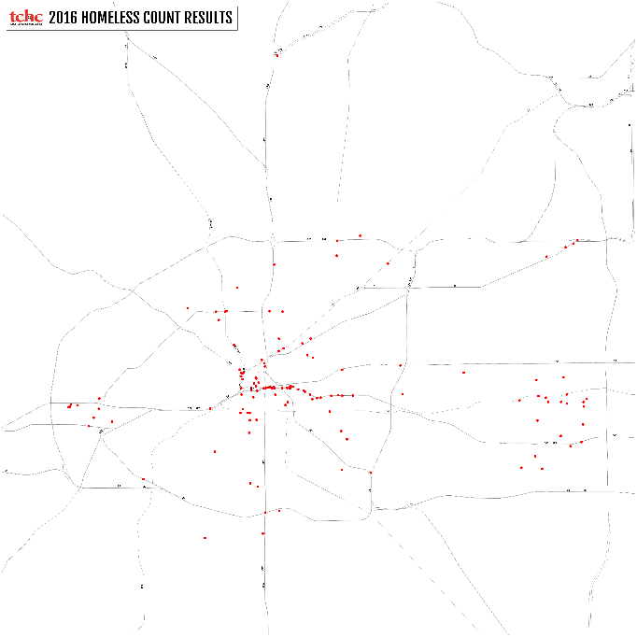
These density maps illustrate the change in the concentration and distribution of unsheltered homelessness between 2015 and 2016.

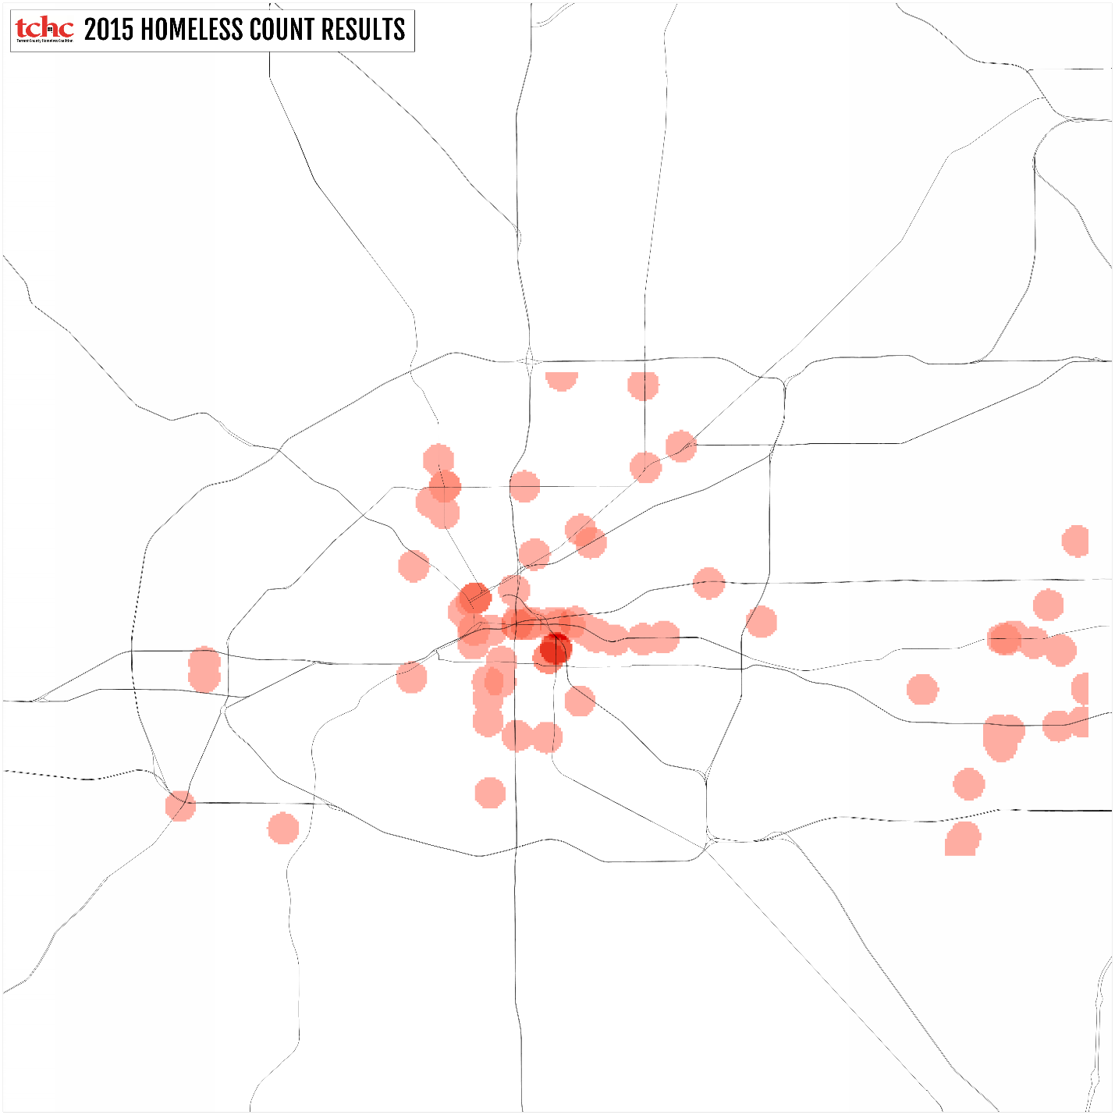

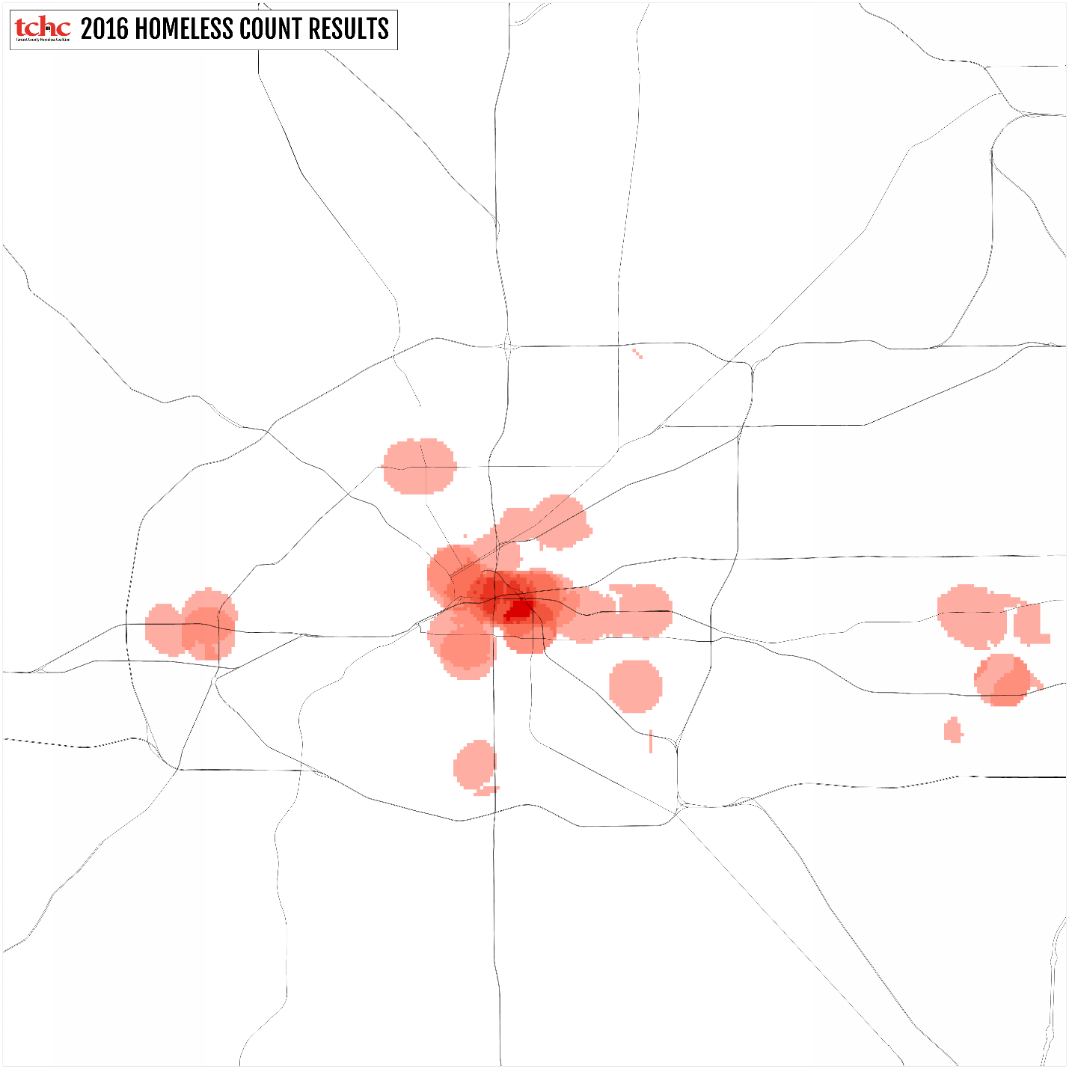

Demographics

 | 2016  Total | Rate
Male | 327 | 77%
Female | 95 | 22%
Transgender | 1 | .3%

 | Total | Percent  of Total
White | 224 | 53%
African American | 164 | 39%
Asian | 4 | 1%
American Indian/  Alaska Native | 5 | 2%
Native Hawaiian/  Other Pacific Islander | 3 | 1%

 | Total | Percent  of Total
Hispanic | 57 | 13%
Non-Hispanic | 366 | 87%

 | Total | Percent  of Total
Children under 18 | 15 | 4%
18-24 | 32 | 8%
25-64 | 360 | 85%
65 and over | 16 | 4%

Top Reasons Reported for Unsheltered Homelessness
 | Male | Female
1 | Unable to Pay Rent / Mortgage | Unemployed
2 | Unemployed | Unable to Pay Rent / Mortgage
3 | Family or Personal Illness | Addictions / Substance Abuse

Residence Prior to Homelessness
 | Number | Rate
Tarrant or Parker County | 77 | 19%
Elsewhere in TX | 61 | 15%
Out of State | 48 | 12%

Emergency Shelter

Geographic Distribution

 | Fort  Worth | Arlington | Parker  County | NE  Tarrant | Total | Annual  Change
2016 | 950 | 138 | 0 | 0 | 1,088 | -13%
2015 | 1,112 | 133 | 0 | 0 | 1,245 | --

Demographics

 | Total | Percent  of Total
Male | 659 | 61%
Female | 429 | 39%
Transgender | 0 | 0

 | Number | Percent  of Total
Children under 18 | 205 | 19%
18-24 | 44 | 4%
25-64 | 820 | 75%
65 and over | 19 | 2%

 | Number | Percent  of Total
White | 482 | 44%
African American | 559 | 51%
Asian | 12 | 1%
American Indian/  Alaska Native | 2 | .2%
Native Hawaiian/  Other Pacific Islander | 5 | .5%

 | Total | Percent  of Total
Hispanic | 110 | 10%
Non-Hispanic | 978 | 90%

Transitional Housing

Geographic Distribution

 | Fort  Worth | Arlington | Parker  County | NE  Tarrant | Total | Annual  Change
2016 | 173 | 134 | 0 | 100 | 407 | -6%
2015 | 187 | 112 | 0 | 133 | 432 | --

Demographics

 | Total | Percent  of Total
Male | 207 | 51%
Female | 200 | 49%
Transgender | 0 | 0

 | Total | Percent  of Total
Children under 18 | 152 | 37%
18-24 | 19 | 5%
25-64 | 215 | 53%
65 and over | 21 | 5%

Safe Haven

Geographic Distribution

 | Fort  Worth | Arlington | Parker  County | NE  Tarrant | Total | Annual  Change
2016 | 20 | 0 | 0 | 0 | 20 | 0%
2015 | 20 | 0 | 0 | 0 | 20 | 0%
2014 | 20 | 0 | 0 | 0 | 20 | 0%
2013 | 18 | 0 | 0 | 0 | 18 | +11%

Demographics
 | Total | Percent  of Total
Male | 9 | 45%
Female | 11 | 55%
Transgender | 0 | 0%

Families and Youth

Persons in  Families | UN | ES | TH | SH | Total | Change
2016 | 25 | 291 | 243 | 0 | 559 | -.7%
2015 | 0 | 302 | 261 | 0 | 563 | -45.60%
2014 | 0 | 319 | 716 | 0 | 1035 | -6.59%
2013 | 0 | 355 | 753 | 0 | 1,108 | 30.05%

Family Households | Total | Average  Size
2016 | 183 | 4.21
2015 | 182 | 3.09
2014 | 321 | 3.22
2013 | 336 | 3.30
2012 | 326 | 2.61
2011 | 291 | 3.16

Households by Type | UN | ES | TH | SH | Total
Family Households: Adult & Child | 8 | 96 | 79 | 0 | 183
Households Adults Only | 399 | 786 | 163 | 20 | 1,347
Households Parenting Youth: 18-24 | 0 | 21 | 10 | 0 | 32

Children (<18) | 2016  Total | 2015  Total | Annual  Change
Unsheltered | 15 | 0 | --
Emergency Shelter | 194 | 219 | -11%
Transitional Housing | 152 | 161 | -6%
Safe Haven | 0 | 0 | 0%
Total | 361 | 380 | -5%

Veterans

 | UN | TH | ES | SH | Rate | 2016  Total | 2015  Total | Annual  Change
Veterans | 30 | 98 | 76 | 1 | 11% | 205 | 193 | +6%

Selected characteristics of unsheltered veterans.
 | Total | Percent  of Total |  |  | Total | Percent  of Total
Army | 15 | 50% |  | Male | 29 | 97%
Marine Corps | 6 | 20% |  | Female | 1 | 3%
Navy | 3 | 10%
Air Force | 1 | 3%

Age | Total | Percent  of Total |  |  | Total | Percent  of Total
18-24 | 2 | 7% |  | Veteran Only | 29 | 97%
25-64 | 22 | 81% |  | Veteran with Child | 1 | 3%
65 and Up | 3 | 11%

 | Total | Percent  of Total
White | 19 | 63%
African American | 9 | 30%
Asian | 0 | 0%
American Indian/  Alaska Native | 0 | 0%
Native Hawaiian/  Other Pacific Islander | 2 | 7%

 | Total | Percent  of Total
Hispanic | 3 | 10%
Non-Hispanic | 27 | 90%

Chronically Homeless

 | UN | TH | ES | SH | Rate | 2016  Total | 2015  Total | Annual  Change
Chronic | 80 | 0 | 70 | 9 | 8% | 159 | 136 | +17%

Sub-populations

 | UN | TH | ES | SH | Rate | 2016  Total | 2015  Total | Annual  Change
Severely Mentally Ill | 89 | 94 | 287 | 19 | 19% | 376 | 459 | -18%
Persons with HIV/AIDS | 4 | 10 | 22 | 0 | 1% | 26 | 20 | +30%
Victims of Domestic Violence | 5 | 30 | 267 | 2 | 17% | 337 | 328 | +3%
Chronic Substance Abuse | 50 | 111 | 163 | 6 | 11% | 213 | 334 | -36%
Veterans | 30 | 98 | 76 | 1 | 8% | 205 | 193 | +6%

Other Individuals in the Care of the Homeless Services System
Individuals and families are not counted as homeless for the duration of time that they are participants in permanent supportive housing or rapid re-housing programs. Because these PSH and RRH programs are operated by continuum of care agencies and constitute a significant body of work, participant data helps to round out our understanding of the overall system of care and inform our understanding of who is receiving services.

Individuals in Permanent Supportive Housing

January 28, 2016 | Adults | Children | Total  Persons |  | Families
Total | 1,150 | 272 | 1,422 |  | 448

 | Number | Rate
Male | 622 | 54%
Female | 527 | 46%
Transgender | 1 | 0.09%

 | Total | Percent  of Total
Under 18 | 272 | 21%
18-24 | 64 | 5%
25-64 | 942 | 73%
65 and up | 144 | 11%

 | Total | Percent  of Total
Hispanic | 105 | 7%
Non-Hispanic | 1,317 | 93%

 | Total | Percent  of Total
White | 615 | 44%
African American/Black | 774 | 56%
Asian | 4 | 0.29%
American Indian/  Alaska Native | 8 | 0.57%
Native Hawaiian/  Other Pacific Islander | 1 | 0.07%

 | Total | Percent  of Total
Veteran | 82 | 7%
Non-Veteran | 1066 | 93%

Individuals in Rapid Re-housing

January 28, 2016 | Adults | Children | Total  Persons | Families
 | 461 | 328 | 789 | 440

 | Total | Percent  of Total
Male | 203 | 44%
Female | 258 | 56%

 | Total | Percent  of Total
Under 18 | 328 | 43%
18-24 | 43 | 6%
25-64 | 387 | 51%
65 and up | 31 | 4%

 | Total | Percent  of Total
Hispanic | 99 | 13%
Non-Hispanic | 689 | 87%

 | Total | Percent  of Total
White | 245 | 31%
African American/Black | 532 | 68%
Asian | 1 | 0.13%
American Indian/  Alaska Native | 0 | 0%
Native Hawaiian/  Other Pacific Islander | 2 | 0.26%

 | Total | Percent  of Total
Veteran | 119 | 25%
Non-Veteran | 342 | 74%

Annualized Count
In addition to the point-in-time count, the Homeless Management Information System provides a means to measure the number of people who experienced homelessness throughout the year.
 | Total | Percent  of Total
Adults | 5,447 | 81%
Children | 1,259 | 19%
Total | 6,706

Documentation of Priority Status
As part of the Continuum of Care’s Coordinated Assessment System, TCHC reviews case files for verification of homelessness, disability, and severity of service needs. Households are prioritized for housing on scale of relative need.
 | Total | Percent  of Total | Housed | Percent  of Total
Homeless Individuals Prioritized | 794 | -- | 302 | 38%
Verified as Chronically Homeless | 176 | 22% | 81 | 27%
Verified as Non-Chronically Homeless | 610 | 77% | 221 | 73%

Discussion
The Big Picture
The overall number of people who were homeless on Count Night 2016 increased by 24 people (1%) over 2015. While an increase is never welcome, low-income households faced significant obstacles in the just-ended year and Fort Worth may be doing better than other large cities.
Nationally, household incomes fell by 9 percent between 2001 and 2014 as real rents rose 7 percent. Locally, as apartment vacancy rates declined, competition increased for an insufficient and ever shrinking supply of apartments that are both vacant and affordable to very-low income renters.
On the positive side, the homeless services system appears to be increasing its efficiency and volume. As new rapid re-housing programs have come online, families constitute a smaller number and percentage of the overall homeless population.
Unsheltered Homelessness and Panhandling
For many, the standout statistic in this report will be the year-to-year change in the number of people who were sleeping outside on Count Night. Mathematically the change is accounted for by decreases in the number of people sleeping in emergency shelters and transitional housing on Count Night along with the overall population increase of 71 people.
 | Unsheltered | Emergency  Shelter | Safe  Haven | Transitional  Housing | Total
2016 | 423 | 1,088 | 20 | 407 | 1,938
2015 | 217 | 1,245 | 20 | 432 | 1,914
Change | 206 | -157 | -- | -25 | 24

Three notes are important in this regard on weather, panhandling, and reconnaissance.
Weather
The number of people who sleep outside can vary significantly in response to temperatures and precipitation; namely, more people sleep outside when conditions are temperate and dry. The effect appears most pronounced in the areas closest to the High Impact Zone in Fort Worth.

Count Night 2015 was cold and damp; Count Night 2016 was warm and dry. The increase in people sleeping outside is partially offset by a decrease in people sleeping in Emergency Shelters.
Panhandling
There has been an apparent increase in panhandling across the metroplex. However, TCHC concurs with street outreach workers and members of law enforcement that caution against equating panhandling with homelessness. The correlation of panhandling with addiction appears much stronger than the correlation of panhandling with homelessness.
The presence of panhandlers can create traffic safety hazards and, for some drivers and pedestrians, a range of emotions from consternation to pity, dread to outrage. While panhandling is a good indicator that someone is in crisis, it is not a surefire sign that they are homeless. Readers are encouraged to consider the variety of social, psychological, and economic factors that can foster an increase in panhandling and to not assume that everyone who panhandles is homeless.
As the on-going election cycle most certainly reminds us, asking for money is protected speech. TCHC is appreciative of the many police officers in our area who do the hard work of responding to citizen concerns and needs with professionalism and respect.
Reconnaissance
Preparations for the PIT count include gathering information from law enforcement and street outreach professionals on known and suspected locations of homeless encampments. Strategic funding has increased the number of street outreach workers; consequently, Count Night volunteers had more guidance on places to look in 2016 than in any previous count.

Homeless Helpline
While it is clear that far too many households are treading water, their tenacity and resilience combined with a strong employment picture have surely helped to keep overall numbers relatively flat. The TCHC Helpline responded to over 1,200 calls this year.
 | Total | Percent  of Total
Phone Calls | 1,202 | --
Households: Single Adults | 446 | 37.1%
Households: Adult with children | 430 | 35.8%
Callers with a Disability | 262 | 21.8%

Causes and Impediments
Homelessness can be a result of bad luck, bad circumstances, bad choices—or a combination thereof spiraling out of control. For citizens with moderate to high incomes, these factors rarely lead to homelessness; however, those who are low-income or living in poverty are much more susceptible to this spiraling pattern. Homelessness takes a horrific toll on the human body and spirit: in this, it is always personal. Homelessness is also, always social and economic.
Consistently, year after year, the top three causes of homelessness that have emerged from the TCHC data include: inability to afford rent, unemployment, and domestic violence.
CAUSES OF HOMELESSNESS
 | 2015 |  | 2016
 | Men | Women | Men | Women
 | Inability to afford rent | Inability to afford rent | Unemployment | Inability to afford rent
 | Unemployment | Domestic Violence | Inability to afford rent | Unemployment
 | Physical/ Mental Disability | Unemployment | Addictions/ Substance Abuse | Family/ Personal Illness

Many people are surprised to learn that neither mental illness nor addiction are the top cause of homelessness. While behavioral health problems can certainly be the cause of someone’s unemployment—and subsequently their inability to afford rent—a majority of the 10,200 adults that receive treatment each month from MHMR Tarrant do not become homeless.
Shortages of affordable child care, public transportation, and background-friendly employers certainly hinder the ability of low-income households to thrive. In 2016, Count Night volunteers were told that a shortage of affordable housing, employment, health concerns, and domestic violence both caused their homelessness and frustrate their efforts to escape it.

Availability of Affordable Housing
The shortage of housing that is affordable to the lowest-income renters in Tarrant and Parker Counties continues to be the greatest cause of homelessness and one of the most significant impediments to escape. National trends in the availability of affordable rental housing do not bode well for the lowest income renters:
- Renter households increased from 34 million in 2005 to nearly 43 million in 2015. The increase of nearly 9 million renter households between 2005 and 2015 exceeds growth during any 10-year period in recent history.
- The share of all US households that rent rose from 31 percent in 2005 to 37 percent in 2015, its highest level since the mid-1960s.
- The national rental vacancy rate averaged 7.1 percent in the first three quarters of 2015, its lowest point in 30 years and down from a record high of 10.6 percent in 2009.
- Just under 84 percent of renter households with incomes below $15,000 – equivalent to full-time work at the federal minimum wage – were cost-burdened in 2014, with 72 percent facing severe cost burdens (spending more than half of income on housing).
- Excluding units that were physically inadequate or occupied by higher-income renters, there were just 34 affordable rentals for every 100 extremely low-income renters in 2013.
- The average county with a population of 500,000 or more provided only 25 affordable, adequate, and available units for every 100 extremely low-income renters in 2013, with 21 of these units receiving federal housing assistance and only 4 offered by the private market.
In January 2016 occupancy rates in stabilized properties averaged 93.4% Statewide, 94.4% in Greater Fort Worth, and 96% in Parker County. In this context, very-low income renters struggle to compete with higher income renters for a small number of units. For example, there are only 5,245 rental units in the City of Fort Worth that are affordable to households under 30% of the Area Median Income ($20,900 for a family of four).
The National Low Income Housing Coalition’s, 2015 Out of Reach report calculates that to afford the $893 per month Fair Market Rent on a two-bedroom apartment a Tarrant County renter household would need to make $35,720 per year—the equivalent of 95 hours per week at minimum wage. Fully 30% of Tarrant County households do not make enough to afford this rent.

Employment and Poverty
According to the Federal Reserve Bank of Dallas, employment in the metroplex has been strong relative to many other major employment centers:
At year-end 2015, the unemployment rate dipped to 3.8 percent in Dallas and 4 percent in Fort Worth. In contrast, unemployment rose from 4.6 percent to 4.7 percent in Texas. All three figures remain lower than the U.S. rate of 5 percent. Unemployment in both Dallas and Fort Worth remains close to multiyear lows, suggesting a very tight labor market in the metroplex. In 2015, unemployment fell 0.4 percentage points in Dallas and 0.3 percentage points in Fort Worth.
The unemployment rate alone, however, does not paint a full picture as the median income of the lowest income households fell 9% from 2000 to 2014. Around 18% of Texans were below the poverty level in 2013 which included 22% or 110,000 Tarrant County children:
PERSONS IN POVERTY
Location | Data Type | 2009 | 2010 | 2011 | 2012 | 2013
Texas | Number | 4,143,077 | 4,411,273 | 4,627,604 | 4,565,185 | 4,531,427
 | Percent | 17.1% | 17.9% | 18.5% | 17.9% | 17.5%
Tarrant  Overall | Number | 254,582 | 258,595 | 307,362 | 287,871 | 286,019
 | Percent | 14.5% | 14.4% | 16.8% | 15.5% | 15.2%
Tarrant  Children (0-17) | Number | 106,476 | 104,120 | 121,288 | 115,594 | 110,833
 | Percent | 21.2% | 20.7% | 23.8% | 22.6% | 21.5%
So, how much does it take to “get by” in our area? Dr. Amy K. Glasmeier at the Massachusetts Institute of Technology has defined the living wage as the wage needed to cover basic family expenses (basic needs budget) plus all relevant taxes exclusive of publicly provided income or housing assistance.
LIVING WAGE CALCULATIONS
 | 1 Adult | 1 Adult 1 Child | 1 Adult 2 Children | 2 Adults | 2 Adults 1 Child | 2 Adults 2 Children | 2 Adults 3 Children
Living Wage | $10.49 | $21.58 | $24.99 | $8.49 | $11.84 | $13.80 | $15.82
Poverty Wage | $5.00 | $7.00 | $9.00 | $3.00 | $4.00 | $5.00 | $6.00
Minimum Wage | $7.25 | $7.25 | $7.25 | $7.25 | $7.25 | $7.25 | $7.25
Annual Expenses | 1 Adult | 1 Adult 1 Child | 1 Adult 2 Children | 2 Adults | 2 Adults  1 Child | 2 Adults 2 Children | 2 Adults 3 Children
Food | $3,022 | $4,457 | $6,704 | $5,540 | $6,898 | $8,903 | $10,835
Child Care | $0 | $5,318 | $7,977 | $0 | $5,318 | $7,977 | $10,636
Medical | $2,144 | $6,745 | $6,534 | $4,962 | $6,534 | $6,597 | $6,564
Housing | $7,440 | $11,256 | $11,256 | $8,700 | $11,256 | $11,256 | $15,096
Transportation | $4,697 | $8,554 | $9,859 | $8,554 | $9,859 | $11,553 | $11,037
Other | $2,253 | $3,916 | $4,284 | $3,916 | $4,284 | $5,178 | $4,838
Required annual income after taxes | $19,556 | $40,246 | $46,615 | $31,673 | $44,150 | $51,465 | $59,008
Annual taxes | $2,253 | $4,636 | $5,370 | $3,649 | $5,086 | $5,929 | $6,798
Required annual income before taxes | $21,809 | $44,883 | $51,985 | $35,322 | $49,236 | $57,394 | $65,805

Domestic Violence
Domestic violence, including child abuse, elder abuse, and intimate partner violence, continue to devastate the lives of children, women, and men across our community. Persons fleeing or who are attempting to flee domestic violence are considered homeless and are included in the PIT count.
In 2015, the staff of SafeHaven of Tarrant County (SHTC) answered 35,270 calls to their 24-hour crisis hotline, an increase of about 3% over 2014. SHTC provided 45,622 days of service to women and children who needed safe shelter in 2015 and stayed an average of 26 days.
Poverty and a shortage of affordable housing appear to be compounding the difficulties faced by victims of domestic violence, creating an unwinnable choice between homelessness and violence. One long-time SHTC employee described the bind in this way:
When I started working with domestic violence survivors in the shelter years ago, I mostly encountered individuals and families who became homeless for the first time because of abuse. Today our agency sees an increasing number of clients who have experienced multiple incidents of victimization from different abusive partners. We’re seeing so many single moms who are in poverty and not stably housed cycling back through the shelter. They often seek a provider though a relationship with a partner who is stably housed and end up unsafe in a situation that is abusive. Their lack of stable housing and risk of poverty was keeping them in a cycle of victimization.
The vulnerability of these victims becomes more apparent when one considers:
- Apartment vacancy rates in our area are hovering around 5%
- 93% of those seeking shelter from an abuser have an income of less than $20,750
- 40% of the adults seeking shelter from an abuser had a severe mental illness

Functional Zero: What Does it Mean to End Homelessness?
The technologies and capital required to meet the demand for quality, affordable, accessible housing exist in our community today. The technologies needed to address the behavioral, social, and macro-economic factors that contribute to homelessness are more elusive.
While we can envision a day where there is an adequate supply of decent and affordable housing, it is hard to imagine replicable and scalable solutions in the near term to the other, major contributing and confounding causes of homelessness, such as addiction, domestic violence, mental illness, and large scale fluctuations in the economy that cause unemployment and underemployment to spike among low-skill and low-wage workers. In this context, what does it mean to end homelessness?
Increasingly, advocates and continuum of care practitioners are embracing an understanding of functional zero to focus and measure their work. Functional zero is achieved when at any point in time the number of people experiencing sheltered and unsheltered homelessness will be no greater than the current monthly housing placement rate. In other words, in any given month more people will exit homelessness than fall into it. Operationalized in this way, the goal of ending homelessness acknowledges the reality that people will continue to experience housing crisis and focuses efforts on reducing the trauma and public expense of homelessness by decreasing the time anyone must suffer it.

TCHC Recommendations
The work to prevent and end homelessness is a community-wide responsibility.
The Fort Worth/ Arlington/ Tarrant Area Continuum of Care (aka, “TX-601”) was chartered to participate in the Federal Continuum of Care Program authorized by the HEARTH Act of 2009. According to HUD:
The Continuum of Care program is designed to promote community-wide goals to end homelessness; provide funding to quickly rehouse homeless individuals (including unaccompanied youth) and families while minimizing trauma and dislocation to those persons; promote access to, and effective utilization of, mainstream programs; and optimize self-sufficiency among individuals and families experiencing homelessness. The program is composed of transitional housing, permanent supportive housing for disabled persons, permanent housing, supportive services, and HMIS.
Each Continuum of Care (CoC) is required to:
- Operate the Continuum of Care in a manner that is fair, transparent, and collaborative
- Designate and operate an HMIS (Homeless Management Information System) to record, track, and monitor client- and program-level data
- Conduct Continuum of Care Planning

Communities that establish a Continuum of Care are eligible to apply for funding in the annual Continuum of Care Program competition.
TX-601 has selected Tarrant County Homeless Coalition (TCHC) to serve in three official capacities: Continuum of Care Lead Agency; HMIS Administrator; and, Collaborative Applicant. TCHC plays critical and often unique roles in the work our Continuum of Care undertakes to end homelessness; however, TCHC is not the Continuum of Care.
Funding across Federal agencies is increasingly linked to Opening Doors: The Federal Strategic Plan to Prevent and End Homelessness. The goals of the Opening Doors plan were revised in 2015 to include:
- Prevent and end homelessness among Veterans in 2015
- Finish the job of ending chronic homelessness in 2017
- Prevent and end homelessness for families with children and youth in 2020
- Set a path to ending all types of homelessness
In the 2015 Continuum of Care Program Competition, HUD articulated two additional policy priorities that include:
- Strategic Resource Allocation
  - Comprehensive Review of Projects
  - Maximizing the Use of Mainstream Resources
  - Leveraging Resources through Partnerships
  - Reviewing the Efficacy of Transitional Housing
- Using a Housing First Approach
  - Removing Barriers to Entry
  - Centralized or Coordinated Assessment System
  - Client-centered Service Delivery
  - Prioritizing Households Most in Need
  - Inclusive Decision-making
HUD has developed the following seven system-level performance measures to help communities gauge their progress in preventing and ending homelessness:
- Length of time persons remain homeless;
- The extent to which persons who exit homelessness to permanent housing destinations return to homelessness;
- Number of homeless persons;
- Jobs and income growth for homeless persons in CoC Program-funded projects;
- Number of persons who become homeless for the first time;
- Homelessness prevention and housing placement of persons defined by Category 3 of HUD’s homeless definition in CoC Program-funded projects;
- Successful housing placement

HUD has announced its intentions to rely on the HMIS calculations of these indicators in the award of Continuum of Care Program Competition dollars. The HMIS software utilized by TX-601, Efforts To Outcomes will be required to produce these reports in early 2016.
Recommendations Framework
Since the publication of the Federal Opening Doors plan in 2010, Continuums of Care across the United States have been working to take focused, local efforts to end homelessness to an increasingly greater scale. Despite the persistent challenges of poverty, housing affordability, intimate partner violence, and uncoordinated systems of care, many communities have made notable progress in reducing the overall number of people who are homeless, and sub-populations such as veterans and the chronically homeless.
“Collective Impact” is a topic that has received a great deal of attention and interest in recent years, especially among people working on issues that span social sectors—including efforts geared towards economic development, women’s rights, and global warming.
Collective Impact is a framework to tackle deeply entrenched and complex social problems. It is an innovative and structured approach to making collaboration work across government, business, philanthropy, non-profit organisations and citizens to achieve significant and lasting social change.
In recent decades, homelessness has certainly become a social problem that is both entrenched and complex. Moreover, it is increasingly obvious that significant change will be illusive absent the participation and coordination of multiple sectors.
There are five conditions that are believed to promote the achievement of collective impact, including:
- Creation of a Common Agenda
- Establishment of Shared Measures
- Fostering of Mutually Reinforcing Activities
- Continuous Communication
- Backbone Organization

The Continuum of Care’s 2014 – 2015 Strategic Plan incorporated collective impact as a part of the “6th Objective: Lead the Continuum of Care.”
To draw attention to the importance of collective impact, the 2016 Strategic Plan utilizes the conditions of collective impact as its organizing framework. The goals of the Opening Doors plan and the System Performance Measures are incorporated into the Common Agenda and Shared Measures, respectively.

Common Agenda
Our Continuum of Care exists to Prevent and End Homelessness in Tarrant and Parker Counties. Recognizing that there will always be people who lose their housing—by reason of job loss, family violence, or health crisis, etc.—we will consider the goal of ending homelessness to have been met when monthly exits from homelessness exceed monthly entrants to homelessness and no one is homeless for more than 30 days.
TX-601 Goals for 2016 incorporate the goals of the Federal Opening Doors plan and issues of local significance:
- Prevent and end homelessness among Veterans in 2016
- Finish the job of ending chronic homelessness in 2017
- Prevent and end homelessness for families with children and youth in 2020
- Set a path to ending all types of homelessness
- Maximize the efficiency of local resources
- Create a system-wide plan for housing and services

Shared Measures
The metrics by which we will gauge Continuum of Care performance include HUD’s System-level Performance Measures and measures of local significance:
- Length of time persons remain homeless.
- The extent to which persons who exit homelessness to permanent housing destinations return to homelessness.
- Number of homeless persons (overall and by sub-population).
- Jobs and income growth for homeless persons in CoC Program-funded projects.
- Number of persons who become homeless for the first time.
- Successful housing placement.
- AHAR eligibility rate of 100% for all populations and housing types.
- Optimal Resource Utilization.

Mutually Reinforcing Activities
In 2016, TX-601 will foster mutually reinforcing activities by:
- Operating a robust Coordinated Assessment System
- Engaging in shared learning and teaching opportunities
- Promote the adoption of best practices
- Collaborating across agencies to improve the productivity and quality of targeted initiatives:
  - Educational Access and Linkages
  - SOAR
  - Street Outreach

Constant Communication
To optimize communications between and among CoC partners, people who are homeless, and the public, in 2016 TX-601 will:
- Improve the clarity, transparency, and accessibility of CoC Operations, Planning, and Programs.
- Publish a quarterly dashboard report that charts progress on shared measures.
- Upgrade and development of web-based and electronic communication tools that support the operation of the CoC.

Backbone Organization
Efforts will be undertaken in 2016 to strengthen the Continuum of Care Board of Directors and the Tarrant County Homeless Coalition by reviewing and updating:
- CoC Policies and Procedures
- Collaborative Applicant Memorandum of Agreement
- Fee schedules for HMIS and TCHC Membership

About TCHC
TCHC (Tarrant County Homeless Coalition) is a private, non-profit organization that leads, develops, and coordinates strategies and resources to end homelessness in Tarrant and Parker Counties. TCHC serves as the backbone organization of the communitywide effort to efficiently end homelessness.
Board of Directors

Elizabeth Becker, Chair
June Davis, Treasurer
Debby Kratky, Secretary
Paul Harral
Glenn Spoons
Devan Allen
Tammy McGhee
Donald Deshauteurs

TCHC Staff

Otis Thornton, Executive Director
Tammie Caruthers, Office Coordinator
Carolyn Curry, CoC Planning Director
Lauren Helms, CoC Planning Manager
Thomas Brittain, HMIS Manager
J’Qualin Scott, HMIS Coordinator
Lisa Adviento, HMIS Specialist
Holley Wilcox, HMIS Specialist
Amber Puga, DOPS Coordinator
Melanie Pierce, Helpline Coordinator
Stella Pratt, Helpline Specialist
Jonathan Prouty, Social Work Intern

Acknowledgements
The Tarrant County Homeless Coalition is grateful to the many organizations and individuals who helped to make Count Night, this Report, and the State of the Homeless Address & Public Forum possible.

400+ Count Night Volunteers
7 Emergency Shelters
ALN Apartment Data, Inc.
Arlington Blueline
Arlington Police Department
Caroline Petty, Graphic Design
Continuum of Care Board of Directors
Current & Formerly Homeless Guides
Donna Riddick, Community Enrichment Center
Dr. James Petrovich, TCU
Dr. Emily Spence-Almaguer, UNTHSC
Fort Worth PD Planning Staff
Fort Worth Police Department
Frito Lay
Home Depot
Julie Hall, Arlington Housing Authority
Nicholas Ramon, HUD Regional Office
Officer Donna Eldridge, Fort Worth Police
Officer Stephanie Gillespie, Arlington Police
Paula Robinson, Center of Hope
Pizza Snob
Saginaw Police Department
Savannah Ware, GIS and Mapping
Starbucks
Suzonne Evans, Photography
Tarrant County Mayors’ Council
Tarrant County Sherriff Dee Anderson
The Salvation Army Mabee Center & Canteen
Tom Thumb
Tricia Jackson Productions
University Christian Church

Discussion and recommendations in this report are provided by the Tarrant County Homeless Coalition and do not necessarily reflect the views of the TX-601 Continuum of Care Board of Directors.
https://www.hudexchange.info/resources/documents/HomelessAssistanceActAmendedbyHEARTH.pdf
https://www.hudexchange.info/resource/1928/hearth-defining-homeless-final-rule/
Table adapted from HUD Criteria and Recordkeeping Requirements for Definition of Homeless, January 2012, https://www.hudexchange.info/resources/documents/HomelessDefinition_RecordkeepingRequirementsandCriteria.pdf
This section is adapted from the transcript of HUD’s Defining “Chronically Homeless” Final Rule Webinar, January 14, 2016: https://www.hudexchange.info/course-content/defining-chronically-homeless-final-rule-webinar/Defining-Chronically-Homeless-Final-Rule-Webinar-Transcript-2015-01-14.pdf
https://www.hudexchange.info/resource/4847/hearth-defining-chronically-homeless-final-rule/
https://www.hudexchange.info/resources/documents/CoCProgramInterimRule.pdf
https://www.hudexchange.info/resource/4036/point-in-time-count-methodology-guide/
https://www.hudexchange.info/resource/4835/notice-cpd-15-010-2016-hic-and-pit-data-collection-for-coc-and-esg-programs/
This policy was adopted by the CoC Board of Directors to conform with HUD guidance: http://portal.hud.gov/hudportal/documents/huddoc?id=14-12cpdn.pdf
Several Cities have gained national attention by declaring State of Emergency in response to large increases in their homeless counts (see NAEH report: http://www.endhomelessness.org/library/entry/homelessness-a-state-of-emergency-do-local-decisions-have-national-implicat).
America’s Rental Housing: Expanding Options for Diverse and Growing Demand, Harvard University Joint Center for Housing Studies, 2015, p.4.
This geography aligns with the City of Fort Worth’s Primary Directions Home High Impact Zone.
Service volume provided by MHMR Tarrant.
America’s Rental Housing: Fact Sheet, Harvard University Joint Center for Housing Studies, 2015, http://www.jchs.harvard.edu/sites/jchs.harvard.edu/files/2015_jchs_rental_report_key_facts.pdf
ALN Monthly News, ALN Apartment Data, Inc., February 2016, Volume 25, Issue 2.
Neighborhood Services Department Presentation of HUD data to Pre-Council on January 12, 2016.
Out of Reach 2015, National Low-income Housing Coalition, http://nlihc.org/oor/texas
American Community Survey 5-Year Estimates, 2010-2014, US Census Bureua
DFW Economic Indicators, Federal Reserve Bank of Dallas, January 26, 2016: http://www.dallasfed.org/assets/documents/research/indicators/dfw/2016/dfw160126.pdf
The American Middle Class Is Losing Ground, Pew Research Center, December 9,2015: http://www.pewsocialtrends.org/2015/12/09/the-american-middle-class-is-losing-ground/
Kids Count Data Center, Annie E. Casey Foundation, http://datacenter.kidscount.org/data/tables/3065-poverty-0-17?loc=45&loct=5#detailed/5/6734/false/36,868,867,133,38/any/8190,8191
Terms and charts on the living wage were retrieved from the MIT Living Wage Calculator: http://livingwage.mit.edu/pages/about
Shelter and Crisis Line statistics in this section provided by SafeHaven of Tarrant County.
Adapted from the Zero2016 campaign: https://cmtysolutions.org/sites/default/files/zero2016glossary.pdf
CoC Program Interim Rule (Formatted Version), p. 9: https://www.hudexchange.info/resource/2035/coc-program-interim-rule-formatted-version
The plan is available on the website of the United States Interagency Council on Homelessness: https://www.usich.gov/opening-doors
The original work describing collective impact and the conditions that foster it was published by John Kania & Mark Kramer in the Winter 2011 issue of the Stanford Social Innovation Review: http://ssir.org/articles/entry/collective_impact
From the Australian community of practice website: http://www.collaborationforimpact.com/collective-impact/

