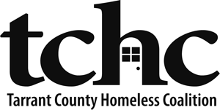

FY 2015 CoC Intent to Renew
Due Date: September 28, 2015, 12:00 PM
Submit Document to: lauren@ahomewithhope.org

Renewing Project Information (Please complete one form per project)

Recipient:
Subrecipient(s):
Project Name:
Grant Number:
Project Type (PSH, RRH, TH):
Current Funding Level
(Must match FY 2014 GIW):
Current Grant Balance in eLOCCS:
Anticipated amount of your renewal:
Brief description of significant changes (e.g., match challenges necessitate reduction, plan to switch project type):

Primary Point of Contact:
Telephone: | ( ) | Email:

Additional contacts to copy on email updates about the FY 2015 Intent to Renew and CoC application process:

First Name | Last Name | Email Address

Applicant Attestation
I understand and agree:

_____  Initial | Time is of the essence in all aspects of the Continuum of Care Program, including the Intent to Renew, application, and reporting: our organization will meet all deadlines and work quickly to correct deficiencies, provide requested information, and support the community-wide application process and implementation of the program.
_____  Initial | Corrections, clarification, updates, and supplemental information will be posted to the TCHC website throughout the application process; therefore, our organization will regularly review the content on the webpage, http://www.ahomewithhope.org/funding-opportunities/.
_____  Initial | It is our responsibility to contact TCHC if changes in the contact information for the point of contact for this application are needed.

________________________ ____________________________ ___________
Printed Name & Title | Signature | Date

